Making it Easy for You and Your Family to be Involved In Our Community

46th District Democrats’
“Community Action Fair”

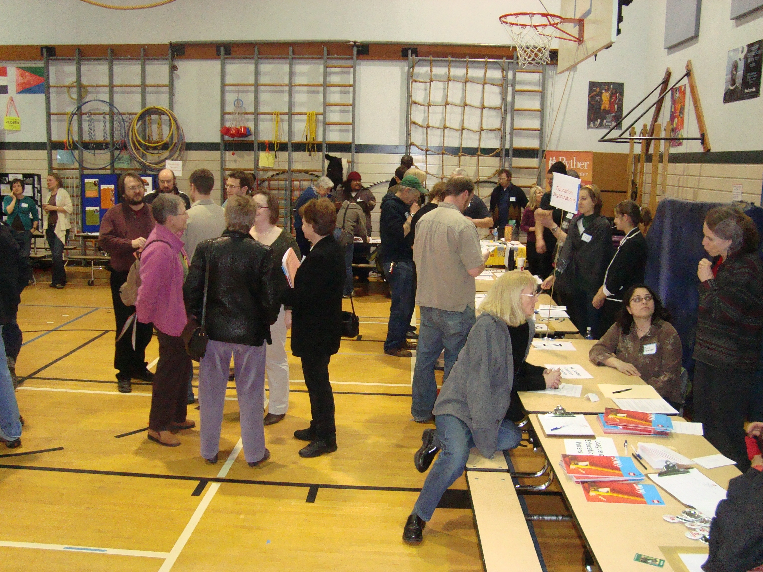

Celebrating the Spirit of Involvement

Thursday January 21st 7:30 p.m.
Olympic View Elementary
(NE 95th Street at 8th Ave.NE)
Refreshments

Special guest, Darryl Smith,
Deputy Mayor for Community Outreach

Organizations serving North Seattle will have tables and discuss how you and your family can become involved. Featuring: food banks, tutoring programs, community councils, groups working to save trees, improve our local schools, improve our parks, or address development and transportation issues.

Learn about the work of local non-profits and community groups serving our District. Find out how you can help - whether you have an hour a month or ten hours to volunteer, high school community service hours to earn, or how your emails and comments help our community.

The Community Action Fair will feature up to two dozen local groups, and will also offer an opportunity for you to meet our new Deputy Mayor, and provide input to the local action section of the 46th District Democrats’ Platform.

Questions or info: Gerry Pollet, Program chair (gerry-pollet@msn.com), or Peter Shapiro, Outreach chair (outreach@46dems.com)

